**ASSESSMENT-1**

**ETHICAL HACKING EXTERNSHIP**

**NAME: KIRAN MANIKANDHAN**

**REG NO: 20BCE1786**

**VIT CHENNAI**

Aim:

The following assessment aims to test your understanding and practical knowledge of various Linux commands. Perform the tasks given below using the appropriate commands. Write down the command(s) used to complete each task. You can use any Linux distribution or command-line interface of your choice. Ensure that you provide the correct output or results for each task.

Commands:

1) File and Directory Operations:

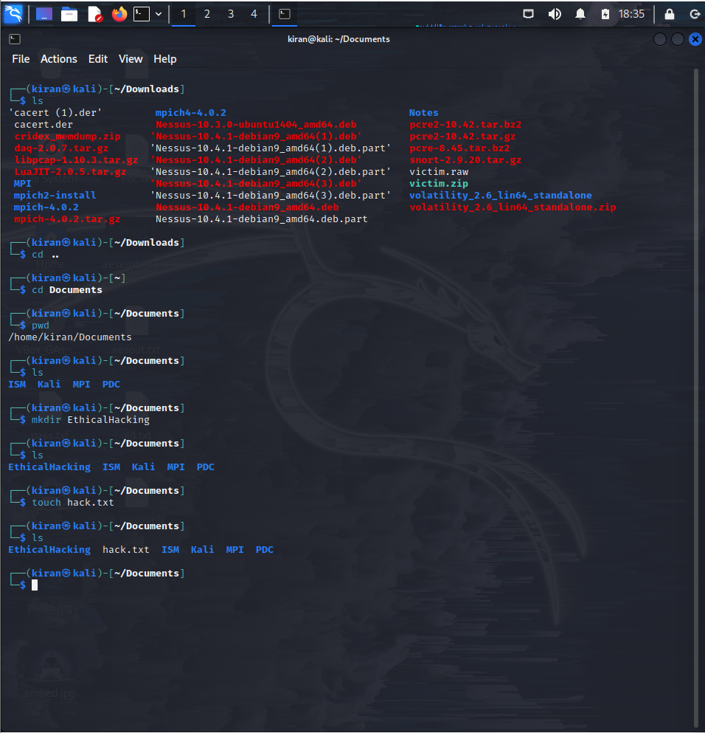

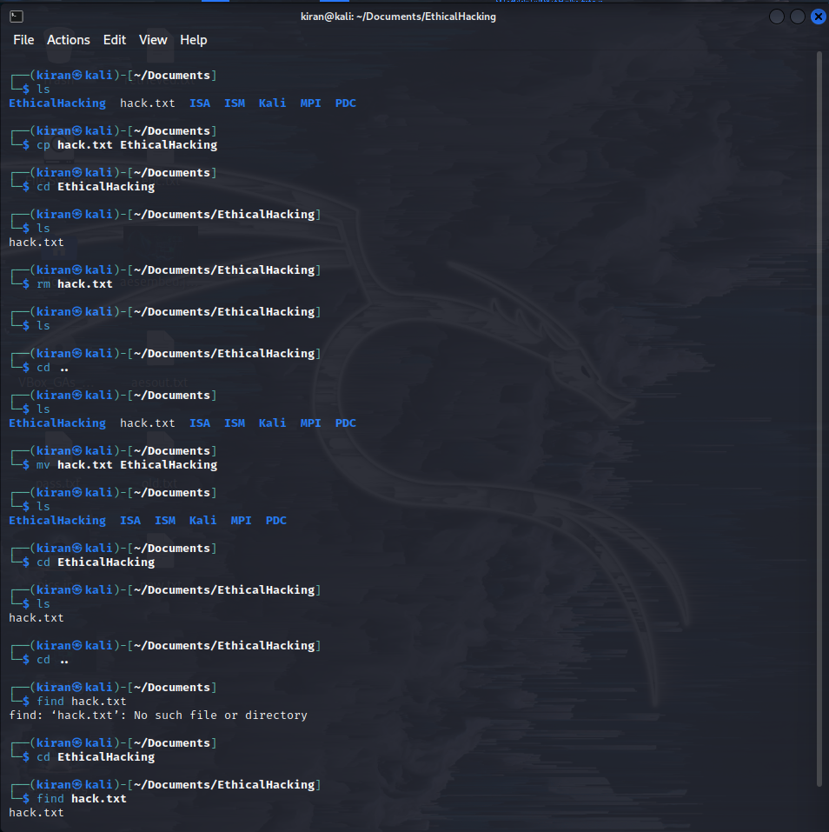

2) File Viewing and Editing:

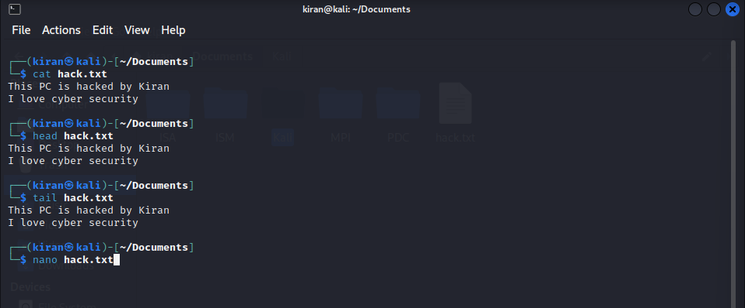

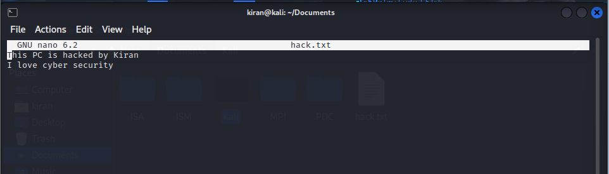

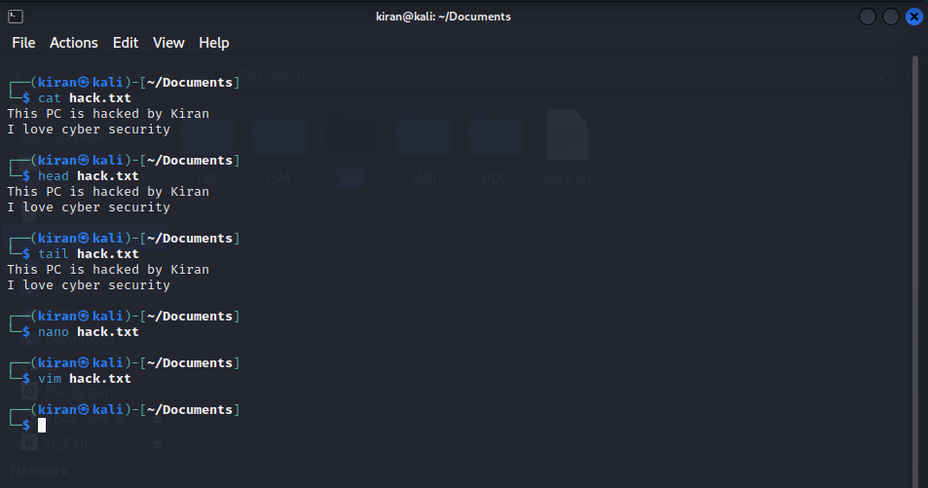

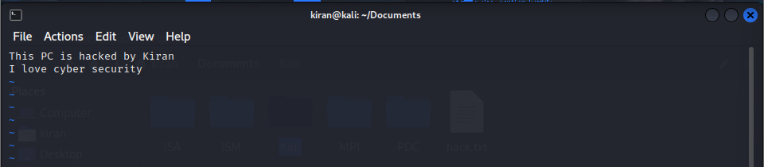

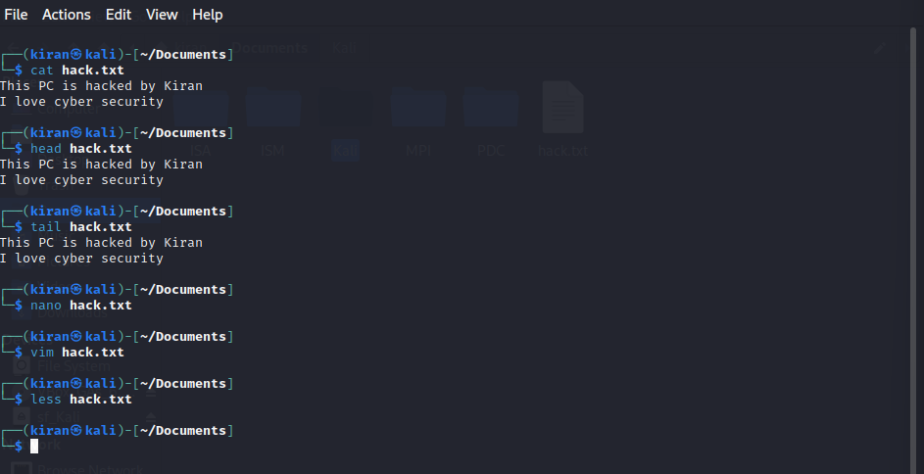

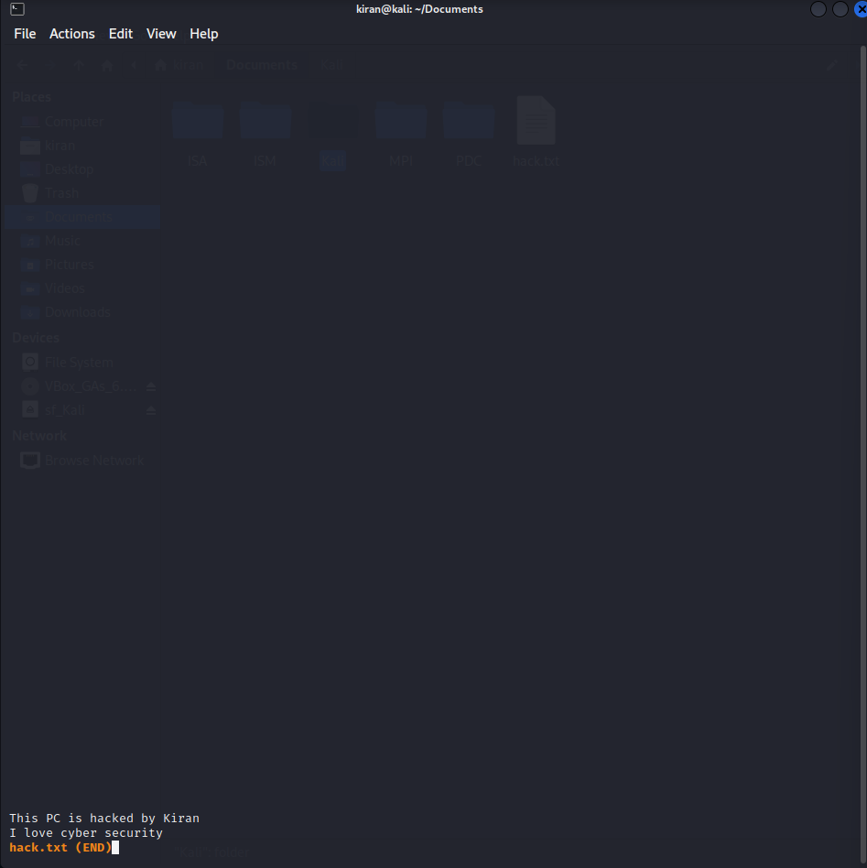

3) File Permissions:

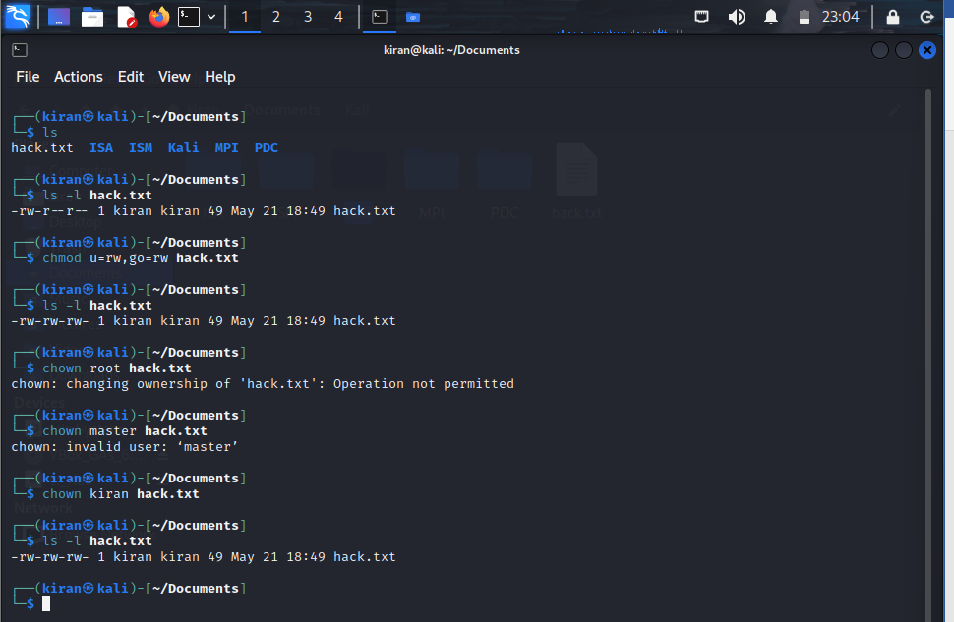

4) File Compression and Archiving:

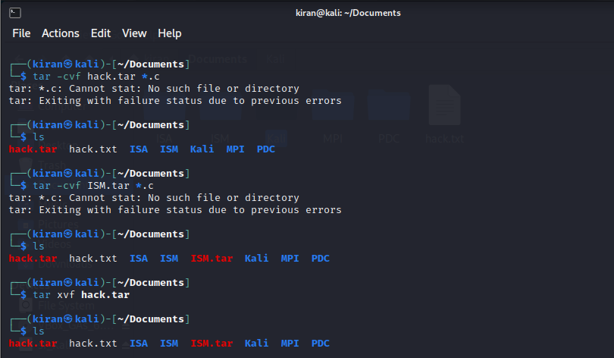

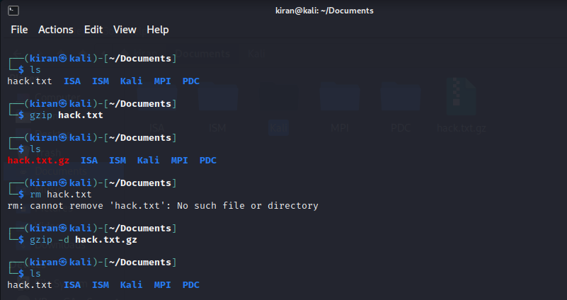

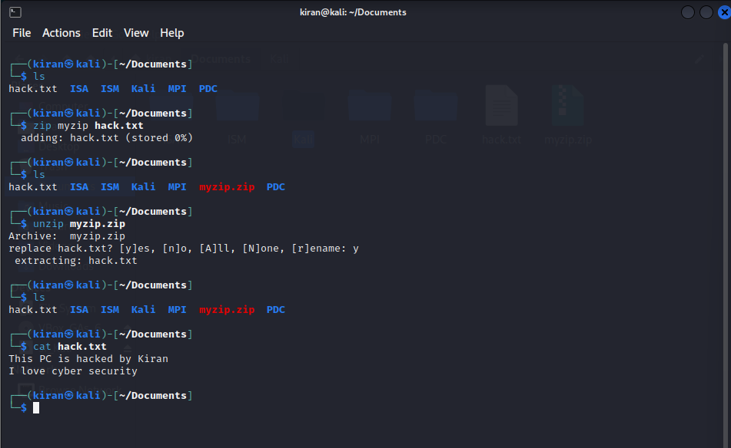

5) Process Management:

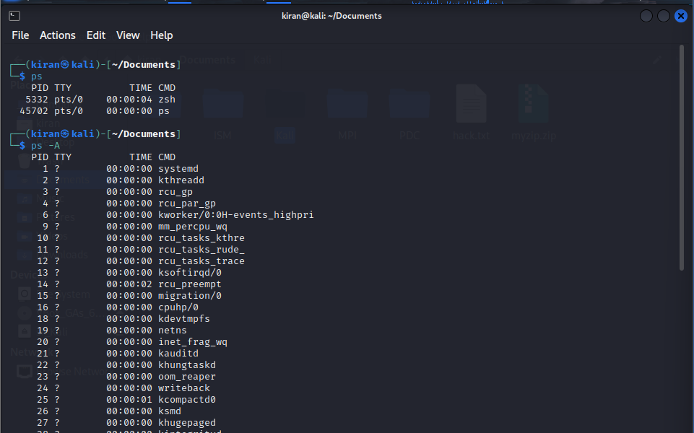

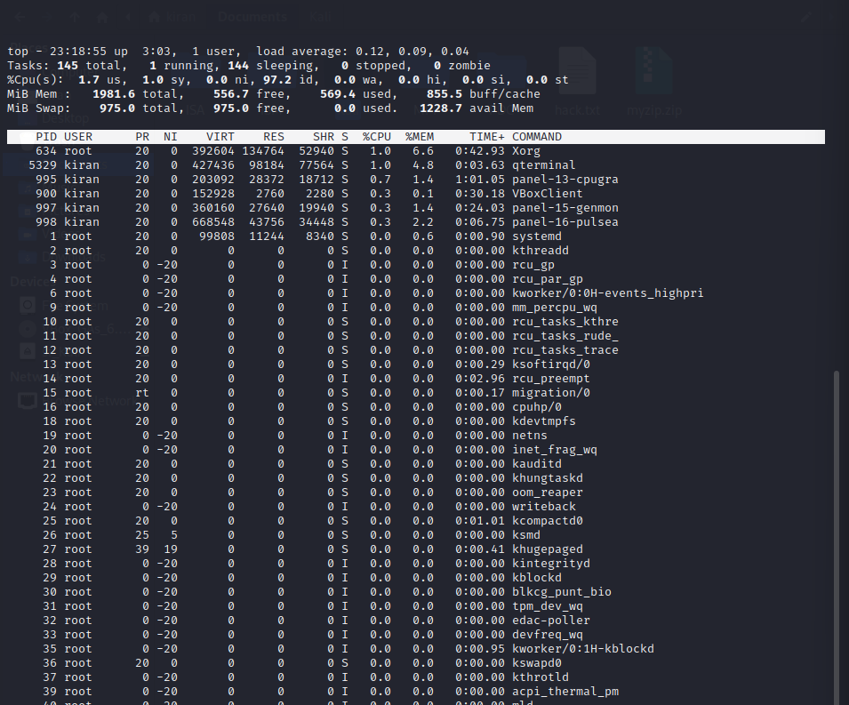

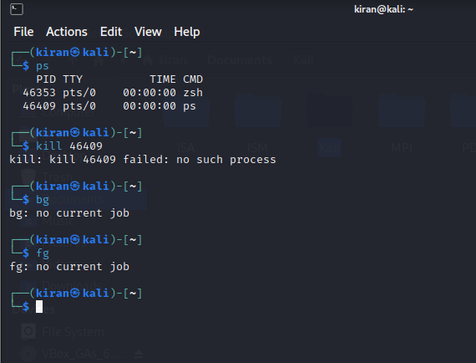

6) System Information:

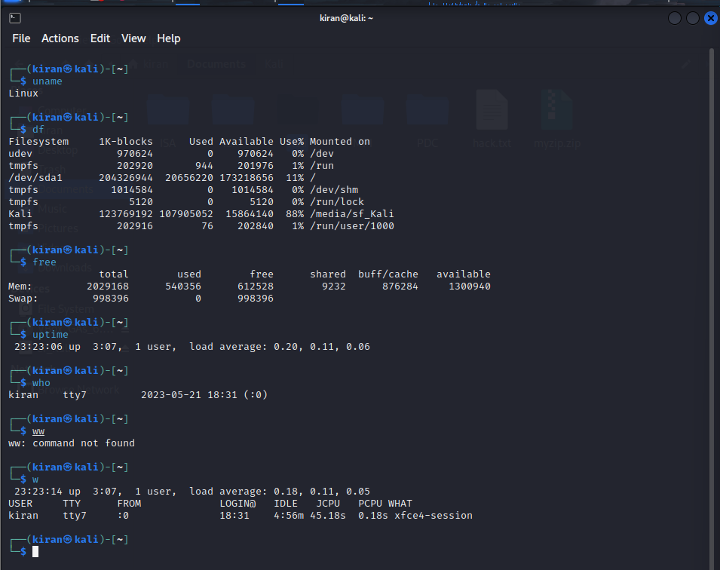

7) Networking:

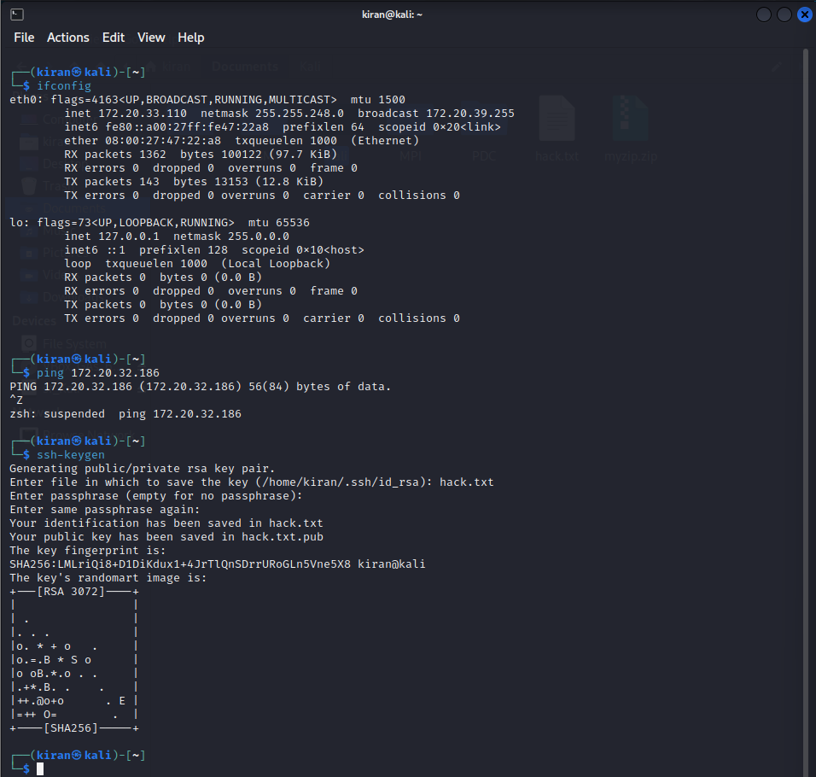

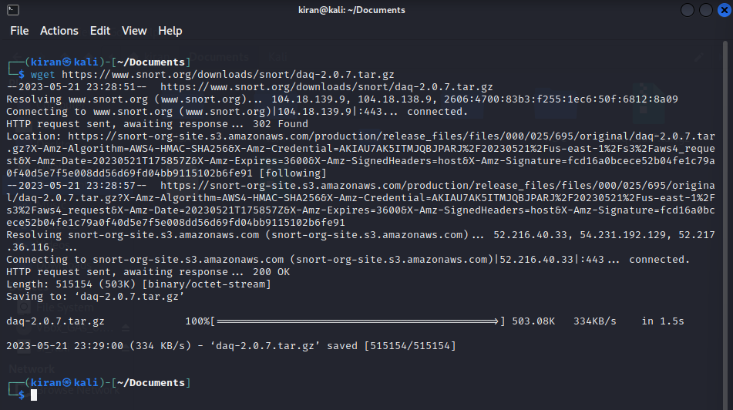

8) System Administration:

